Bakery E-Commerce Project

By: Clara Gehm

# Project Requirements

## Data Requirements

* Store menu information.
* Store drink flavorings.
* Store customer information along with their payment info.
* Store order information.

## Use Cases

* A user must be able to view the menu.
* A user must be able to have an accurate list of their payment methods and submit an order form.

# ER Diagram

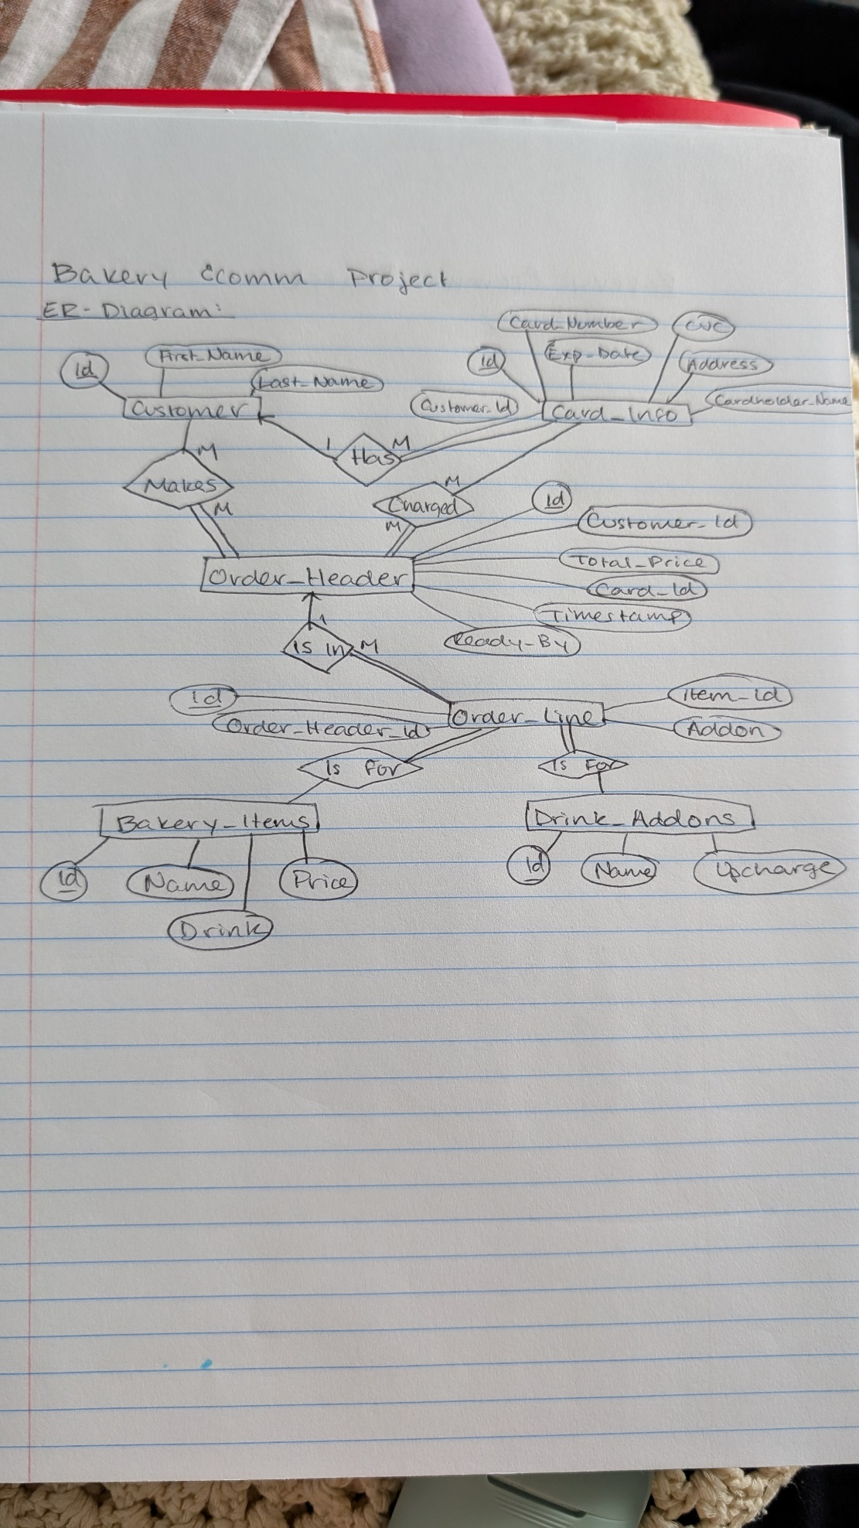

# Schema Design

